Create more… Potato prints
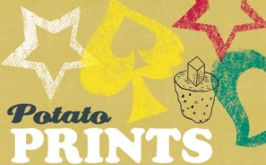

A fun activity for a wet day, using the humble spud…

Suitable for Beavers+
If it’s pouring with rain and you have to spend a day indoors, don’t get down in the dumps. It’s a grand opportunity for trying your hand at potato printing. Be sure to have an adult on hand to supervise the knife work, as you need to use a sharp blade.
You will need
• Potatoes
• A sharp knife (adults should assist here)
• Ink or paint
What to do
1 Find a potato. Wash it, dry it, and then carefully cut it in half with a good sharp knife.
2 To print in a diamond pattern, take one half and mark out a diamond shape with a pencil.
3 For printing ink, try real printers’ ink, stiff watercolour paint or a tube of oil paint.
4 Spread the colour thinly and evenly on a slate or flat piece of wood.
5 Take a postcard or a clean sheet of paper and start making designs with your stamp.
6 Later on you can make all sorts of other shapes – squares, crescents, stars, semi-circles and so on.
Cook an egg the backwoods way
No pans to cook your eggs? Let the potato come to the rescue…
Cut the top off a potato, hollow out and break in an egg. Replace the top part of the potato and wrap in two layers of foil. Cook the potato in hot ashes and you will scoop out a beautifully cooked egg.

