[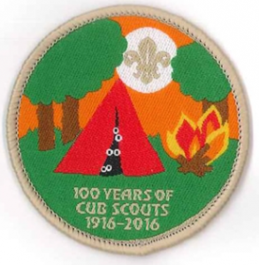](http://www.1stlondoncolney.co.uk/100-y)

1St London Colney Cub Pack

St Albans District Cub Centennial Camp

Date: Friday 13th May 2016 to Sunday 15th May 2016

Location: Tomlers Camp Site

Tolmers Road  
Cuffley  
Hertfordshire  
EN6 4JS

Cost: £40.00 per cub

£25.00 if just attending Saturday (this includes lunch and evening meal)

Payment: A deposit of £10.00 per cub is required by January 29th 2016 and the balance to be paid in full by April 1st 2016

Please male all payments direct to **“St Albans District Scouts”**

All cheques made out to St Albans Distract Scouts and send to:

St Albans District Cub Centennial Camp

c/o Jane Coote

2 Cottonmill Crescent

St Albans

Herts

AL1 1HW

Include the name(s) of the cub(s) and the 1st London Colney Scout Group on the reverse of the cheque.





I would like to inform you that my child ________________________ will be attending the St Albans District Cub Centennial Camp.

They will be staying for: Option 1 – Friday 13th May to Sunday 15th May 2016

Option 2 – Saturday 14th May 2016 (only)

I will make payment direct to “St Albans District Scouts”

Signed:_______________________ Date:________________________

[](http://www.1stlondoncolney.co.uk/100-y)1St London Colney Cub Pack

St Albans District Cub Centennial Camp

Itinerary of Events

Friday 13th May 2016

18:30 – 19:00 Arrive

19:30 – 20:00 Welcome and flag break

20:00 – 21:00 Wide Game

21:00 – 22:00 Supper - *(see menu sheet)*

22:00 Bed

Saturday 14th May 2016

07:30 – 08:00 Rise and Shine

08:00 – 09:30 Breakfast - *(see menu sheet)*

09:30 – 10:00 Flag break

10:00 – 13:00 Activities* *(see activity sheet)*

13:00 – 14:00 Lunch - *(see menu sheet)*

14:00 – 17:00 Activities* *(see activity sheet)*

17:00 – 18:00 Wind down time

18:00 – 20:00 Evening Meal - *(see menu sheet)*

20:00 – 21:00 Camp Fire

21:00 – 22:00 Supper - *(see menu sheet)*

22:00 Bed

Sunday 15th May 2016

07:30 – 08:00 Rise and Shine

08:00 – 09:30 Breakfast - *(see menu sheet)*

09:30 – 10:00 Flag break

10:00 – 12:00 Activities* *(see activity sheet)*

12:00 – 13:00 Pack Kit

13:00 – 14:00 Lunch - *(see menu sheet)*

14:00 – 15:00 Wind down time

15:00 – 16:00 Presentation and Camp Closing Ceremony

16:00 Depart

[](http://www.1stlondoncolney.co.uk/100-y)1St London Colney Cub Pack

St Albans District Cub Centennial Camp

Menu

Friday 13th May 2016

21:00 – 22:00 Supper Hot Dogs & Hot Chocolate

--------------------------------------------------------------------------

Saturday 14th May 2016

08:00 – 09:30 Breakfast Cereals and Porridge

Egg, Bacon, Sausage and Beans

13:00 – 14:00 Lunch Filled Rolls and Chips

Fruit Cake

18:00 – 20:00 Evening Meal Spaghetti Bolognese or

Veggie option

Sticky Toffee Pudding

21:00 – 22:00 Supper Hot Chocolate and Smores around

the camp fire

--------------------------------------------------------------------------

Sunday 15th May 2016

08:00 – 09:30 Breakfast Cereals and Porridge

Egg, Bacon, Sausage and Beans

13:00 – 14:00 Lunch Filled Rolls and Chips

Fruit Cake

--------------------------------------------------------------------------

Squash / water available all day

[](http://www.1stlondoncolney.co.uk/100-y)1St London Colney Cub Pack

St Albans District Cub Centennial Camp

Activities

Tomlers Activities

* Air Rifles
* Canoeing
* Archery
* Rolling Rock



* Assault Course

On Site Activities

* 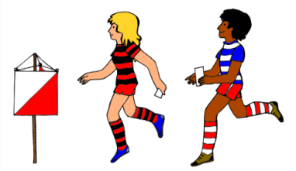Backwood Skills
* Cardboard Ovens
* 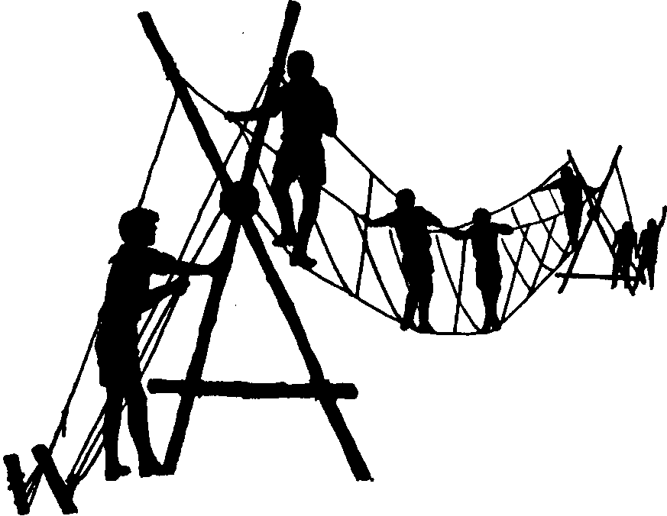Orienteering
* Woggle Making
* Pioneering

Though there are a lot of activates available, each Cub cannot be guaranteed to do them all due to the number attending form the district.

[](http://www.1stlondoncolney.co.uk/100-y)1St London Colney Cub Pack

St Albans District Cub Centennial Camp

100 years Cub Camp Badge Competition

As part of the 100 years celebration of Cub Scouts, the St Albans District is running a competition to design a badge to help celebrate the occasion.

Theme: The theme of the badge is the 100 years of Cub Scouts Camping

Words: The design must have the words, Preferable around the edge;

* St Albans District Cub Camp
* Tolmers
* 100
* May 2016

Lettering must be a minimum of 5 mm high

Colours: The design should consist of no more than 7 colours, plus a background colour and stitching border.

Size: The final design must be able to fit in a 65mm x 65mm square

(2.5 x 2.5 inch)

Closing

Date: All designs need to be in by Monday 1st February 2016, please note the Cubs name and 1st London Colney on the design

Return to: St Albans District Cub Centennial Camp Competition

c/o Jane Coote

2 Cottonmill Crescent

St Albans

Herts

AL1 1HW

The winning badge will be available to all Cubs within the district and can be worn on the back of the scarf